Abstract
This project was based on research to explain fundamentals of how the stock market work and the necessary skills that are needed to make a successful market trader. Through the help of how the marketWorks, an online market trade simulator, I investigated the trends in modern the market. The securities were traded by NYSE which is an American stock exchange offered by the simulator. The project required that I investigate how macro-economics and geopolitics influence and affect the stock market. I performed a 4-week market simulation making important examinations on the market trading strategy and investigating the market sectors. During the trading, I made choices on which companies to invest in based on fundamental analysis of the company’s performance over history. Through the historical analysis, I made a choice to invest in Apple Inc. due to their constant appreciation and advise from analysts who gave recommendations on the company. I also deployed the use of income and growth strategies to make decisions on the potential companies to do the investment in

Acknowledgments
I would like to thank Professor Kirpalani for his tireless guidance and the advice he has given. In addition, HowTheMarketWorks deserves thanks for providing the great simulator that I used to trade stocks and manage my portfolios.

Introduction
I am trying to understand the US stock market various strategies in trading by undertaking a 3-month simulation contest at how the marketWorks. I was provided with real-time data by the simulator and I was allocated $100,000 virtual funds for the project. During the period I was required to make own choice investments to enable me to have a deeper insight and skills in the stock market trade. A set of goals was necessary to keep me on track of what I was supposed to do during the research period.
Goals
During the simulation period, I was supposed to create a portfolio with how the marketWorks. The portfolio should trade in 5 stocks by the end of the investing period.
Invest the virtual cash as much as possible and that at the end of the period I should have no more than $5000 left in the account. To achieve this all the stocks should not be sold at the end of the period.
Research on how macroeconomics and geopolitics influence the stock market.
Question 1
Companies Chosen and Reasons
Apple Inc. (AAPL)
Apple Inc. is an American company that is grouped as a technology powerhouse. It was founded in April 1976 and is located in States. The company designs electronics gadgets and software. AAPL has always enjoyed a double-digit growth rate since 2014. The annual average growth of AAPL stock is almost 13.5%. In 2018 the company had an exceptionally high performance with the prediction of over 28% in net growth. The analysis shows that the AAPL company is expected to have the same growth over the next 5 years. They forecast that on average its net income annually will increase to almost 11.8 % during that time. For these reasons, I chose to buy AAPL securities. With this growth rate, the company will have its shares appreciate over time which will create profit margins on investment.
This is an American company that is based in Seattle, Washington. The company is focused mainly on e-commerce and cloud computing. The company was started in July 1994 by Jeff Bezos as the founder.On the world ranking, it’s the top company in e-commerce revenue.In recent years the U.S sales have been on an increase with a double in the volume of E-commerce sales.This has led to the rapid growth of AMZN with a doubling in just over seven years to 9.1% in the third quarter of 2018. The company is expanding into new potential diversification which increases its profit margin and the overall turnover. In 2018 the third quarter had 66% of AMZN e-commerce sales coming from North America with the remaining 34% coming from other global markets. With this massive achievement, the AMZN shares become attractive to invest in. At 31st January an AMZN share was selling at $1913.77. I bought 20 shares in which 15 were on bought stop-order terms while 5 were on bought market order terms.
Facebook, Inc. (NYSE: FB)
Facebook is an online social media company that provides networking services to its users. Facebook was founded in 2004 by Mark Zuckerberg. The headquarters of Facebook are located in California, United States. In 2019 Facebook has focused on increased investment on the servers, its data centers and the network infrastructure in general. This is a big boost in its performance and is likely to lead to a huge turn over in terms of profits and employment schemes. The total expenses are expected to rise from 40% to 50% (Eassa, 2018). During the fiscal year ending December 2019, a forecast by EPS has shown an increased weekly of 0.14%. The analysts were optimistic that the company was expecting growth in earnings at an average annual rate of 18.18%. This was the game changer for my decision to invest in Facebook. With the forecast by the analyst, I decide to invest in FB by buying 20 shares at a cost of $183.78 as at 3rd Feb.
McDonald’s Corp (NYSE: MCD)
MacDonald’s Corp is a fast food company that was founded in 1940 by Maurice and Richard McDonald. The company operates as a restaurant and offers food to customers. Its headquarters are in California, United States. It’s ranked the world’s largest restaurant chain store and serves over 70 million people daily all over the world. MCD has an annual growth of 4.3% and have shown consistency for the past 5 years and can be a sure choice in the investment plan. MCD has exceeded the entire US hospitality growth of 0.2%with its annual earnings of 14.1% (Baskova, Baska, & Holubcikova, 2016, p. 12). With the constant appreciation of its growth, MCD was an option to invest in. As at 3rd March 2018, the NYSE sold its share at $195.26. I both 30 securities shares.
Question 4.
Effects of Macroeconomics and geopolitics in the stock market
Macroeconomics depicts the decision making, performance and behavior of an economy in the market. During the simulation period, macroeconomics adversely affected the stock market. Boeing airlines were one of the most affected during the simulation period after a catastrophic tragedy that claimed 157 lives in Ethiopian airlines. Countries globally grounded the use of Boeing 737 for fear of malfunction in its design. During the period Boeing massively lost its value which recorded the biggest volatility ever recorded in that month. The price tumbled sharply 5% during the tragedy month. People all over the world developed fear in boarding the plane. Potential investors shied away from purchasing the shares
Geopolitics refers to the political influence of governments who are the regulators of the economy. In the second week of February, the question of President Trump’s stability and agenda significantly affected the stock market. Trade wars with China result in a scrambling market for AAPL after Huawei gadgets from China were being scrubbed from use in the US. This political heat saw a decline in AAPL stock value. Potential investors were met with uncertainty due to the occasional sell-offs.
Question 5.
Weekly Simulation Reports
Journal for Week of JAN. 20th – JAN. 26th, 2019
This week 1st week I chose to trade in the technology sector. I bought 60 shares of APPL at $208.6 spending a total of $12516.0. The stock market during this week had increased in value rising to a high of $208.8. After the spectacular December, the stock markets got hit by volatility which had not stopped yet and I strongly felt the valuation of companies was too high. Remarks made by the president of the US had strongly affected the volatility. To avoid the risk of scrambling market on 26th I sold three-quarters of my shares with a gain of 0.1%.
Journal for Week of JAN.27th – FEB. 3th, 2019
During this week the stock market prices were stable. I decide to invest in e-commerce sector and communication companies. In this case, I to make decisions on the competitive nature of the available companies. On e-commerce, AMZN had the best overall prices plus its performance index over the past 6 months had recorded a steady rise. AMZN shares were selling at $1913.77. I decided to buy 15 shares on stop order terms where I fixed the stop price at $1913.67 and left an allowance of losing 10 cents. The remaining shares I purchased them on a market order term. On the communication sector, I did my research and found out that among the many communication companies FB was having a rising at the price of its share for the past 4 weeks. I decided to make a short-term investment with a face by buying 20 shares at a price bid of $183.78. I used a total of $3675.6 on the FB shares. I closed the week without selling any of my shares since the performance on each at the end of the one-week period was still promising.
Journal for Week of FEB. 4th – FEB. 10th, 2019
On the opening of this new week, I sold all my Apple shares because the selling prices of iPhones were peaking. The threshold prices for iPhones had reached its level best. iPhones drive 70% of AAPL total revenue and when their prices reach the peak it’s an advisable time to sell the securities. I sold all my 15 AAPL shares at a price of $209.10 which was the highest recorded that month accumulating a total of $3136.5 with a profit margin of 0.7%. Having sold all my AAPL shares I decide to venture into the tertiary sector whereby I chose to invest in MCD by buying shares which were being sold at $195.26. With no much significant profits decide to opt for a long-term investment with the company and bought 50 shares of MCD which costed a total of $9763.
Journal for Week of FEB.21TH – FEB. 27th, 2019
On Feb 21^{tst}, I chose to sell a fraction of my FB shares because their market was stagnant. At the time the FB shares were trading at $182.76 and they had been stagnant for 3 days now. I sold 10 shares and on selling the shares I made a loss of 0.5% of the funds invested on the FB stock. The GOOG shares look like the best option to trade with during the period I bought 32shares as the overall weekend had c constant +0.3 raise in the stock value for two days straight.
Journal for Week of MAR. 18th – MAR 24th, 2019
The AAPL shares were fast rising recording the highest from the night of 18th March through the whole 22nd. Having noticed the constant rise on the first day I purchased 50 shares at $207.23 totaling to $10361.5 still anticipating to add more if the trend was constant three days down. I had interest Boeing CO(NYSE: BA) but their market had crushed sharply by 5% after one of their planes getting involved in an accident in Ethiopia. AAPL had announced dividends during the week but due to the great risk involved, I shied away. On 24th the stock was rising steadily with a margin deviation of +0.12 and I added 10 more AAPL shares at $207.81. I closed the market with a net profit of $231 which all investments totaling to $67233 worth of various stock.
Journal for Week of APRIL. 8st – APRIL. 15th, 2019
The stock market for this week had decreased in value generally. Stock prices had fallen after the Labor Department announced jobless claims which showed a high rise than expected. The unemployment rate stood at 3.3% which compounded the investors to be cautious about the gain in stock made in the last third quarter. Firms had laid off most of their human resource which needs scrutiny to determine the future of the shares.
Question6
GOOGLE INC. (NYSE: GOOG)
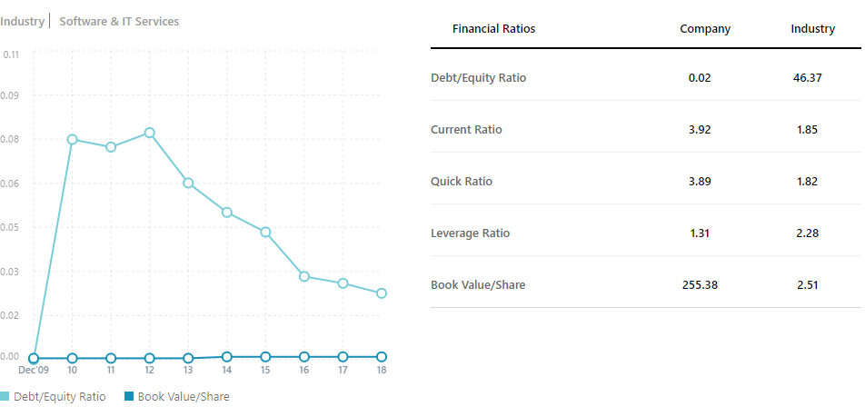
The equity ratio is used to show the amount of equity is used by a company to finance the assets of a company.
Googles company ratio is 0.02
The formulae for Equity ratio = total equity
Total assets
The equity ratio shows the industry how much the company depends on borrowed capital to operate. A small ratio also informs that the firm depends mostly on the owner's capital to generate its products.
FACEBOOK, INC (NYSE: FB)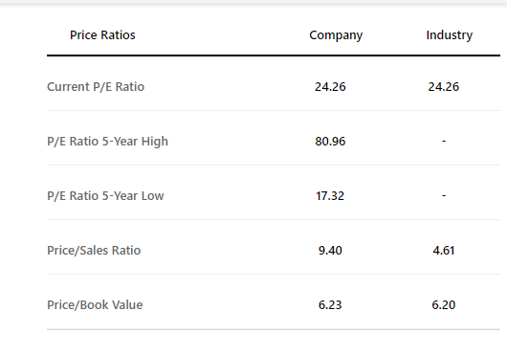
Sales ration-this is a valuation of stock which is a result of dividing the market capitalization of a company by the most recent year revenue. The sale is an indicator of how much a stockholder paid for a single share in comparison to sales that the share generates in the company. Sales ratio show the measure of value that is placed in a company’s share by the stock market. Higher sales ratio indicates that the market is capable of paying for whatever value it grosses annually. A lower sales ratio is an indicator of better value.
The sales ratio for FB is 9.4

$sales ratio=\frac{market share value}{s are the value of a share }$

APPLE Inc. (NYSE: AAPL)
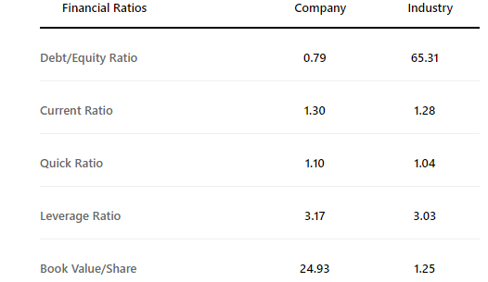
The current ratio of AAPL was 1.30
The current ratio refers to a measure of the ability of a company to meet its short-term obligation depending on its available resources. It shows the ability of a company to meet its liabilities with its funds without disruption of the activities ongoing in the firm. A bigger current ratio shows a higher ability to meet its liability comfortably. A smaller current ratio shows a lack of ability to offset liabilities owned to creditors without disrupting any ongoing activities.
Having a lowered ratio impacts the performance of the firm stock market in the industry negatively. A company that is unable to pay its liabilities is greatly affected in terms of its securities rank in the industry. The shares price depreciates their price for this reason and becomes less attractive to potential investors.
McDonald's (NYSE: MCD)
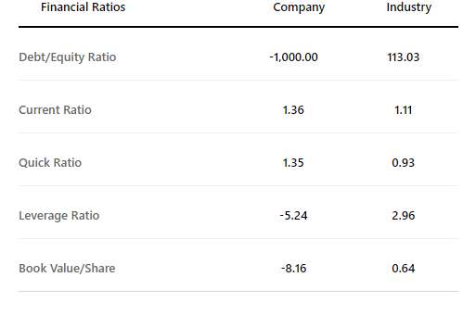
Quick ratio – This is a ratio that shows the potential of a company to liquidate its quick assets to offset its current liabilities.
The formula to calculate quick ratio is
$$\frac{(Cash + Cash Equivalents + Marketable Securities + Accounts Receivable)}{Total Current Liabilities}$$
The quick ratio impacts the company’s overview standing financially. Investors in the market always look at the quick ration to determine the state of the firm to offset its liabilities. Competitors take advantage over the quick ratio to become more attractive to investors since they feel safe investing in them and making them more attractive during business evaluation.
AMAZON (NYSE: AMZN)
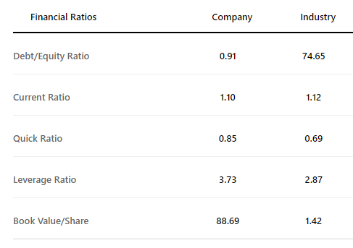
Leverage ratio- Refers to any financial ratio that provides an indication of how the firm's operations are financed including the company's assets. The leverage ratio for AMZN was 3.73. An investor does company valuation on a potential company to invest to gain insight into the worth and risks of the firm just in case he decides to do an investment. Leverage ratios include Debt to assets ratio, Debt to Equity ratio.
Question 7.
From the 5 stock markets that I chose to invest in, AAPL had the greatest market risk of all.
AMZN had the highest volatility index of it shares over the past 3months. AMZN had a mean of 0.2504. This volatility could have brought about by the feuds of the owner Jeff Bezos and his wife after a report of divorce was announced "Amazon.com, Inc. (AMZN) Risk Assessment," 2019).
Question 8.
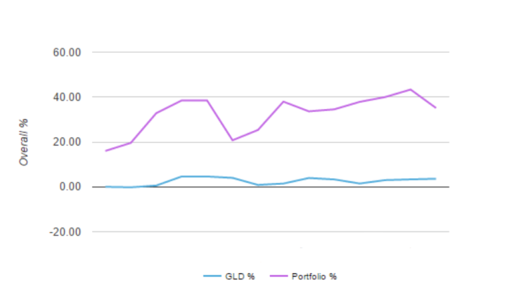
I chose GOLD ETF. The measure of the market represents the market size and consumption of the products over a time period of 3 months. Gold is a determinant of fiscal value since money has faster inflation rate. Measure the market size alongside GOLD ETF index shows the different metrics in determining the health gauges of selling stock shares to avoid stock scramble due to inflation.

Question 9.
The best investment strategy from the order history was value investing.
I strategized on value investing to acquire undervalued shares at cheap prices. I researched through the stocks and found out that google.com Inc. (NYSE: GOOG) stock was greatly undervalued. At the opening of the third week of the simulation investing GOOG was trading at its lowest price ever recorded for the past 3 months. Regarding its raising value statistics of a constant +0.32 in its value during the third quarter of 2018 I had found the right deal that I was certain would start rising within the next week after GOOG announcing new strategies in updating its servers and liquidating is quick assets to offset all the built up liabilities.
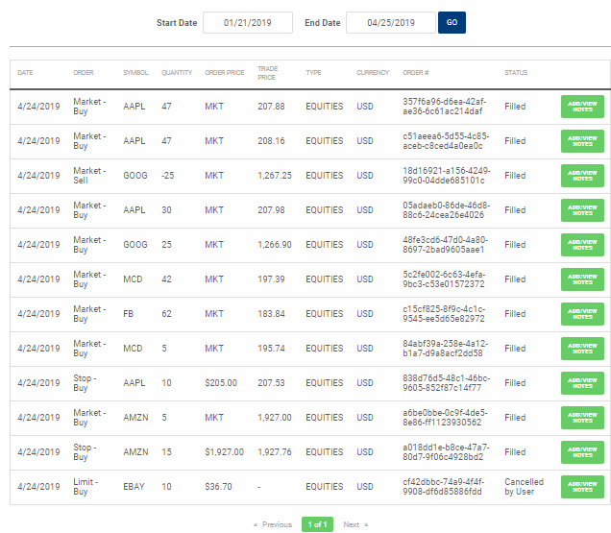
Question 10.
The closing stock was $3424.34
At the closing date of the simulation, I had made a profit of $1300.
Question 11.
To maximize my profits, I would strategize on dividend investment as this could give me a constant income as a long-term investor. The cost basis is also significantly lowered for stock bought.
Conclusion
During the simulation, I chose my favorite firms and deployed the best strategies to create my portfolio at how the marketWorks. The project involved investing in five companies of my own choice during the 3-month simulation period. Transactions made were saved to the class contest group and were used to track and keep records. With HowTheMarketWorks as the simulator, it provided me with real-time NYSE stock market data and virtual funds of $100,000.MY portfolio focused on specific sectors of interest. I chose to invest in tertiary, communication, technology and e-commerce sectors. The sectors were unpredictable with high rates of volatility affecting some of the investments in the portfolio. This has made learn and acquire knowledge in critical decision making regarding which stock markets are most profitable.
To keep a healthy business environment, I also realized the importance of impact investment which focuses on more on social benefits to human beings other than being hooked on profits. The tertiary sector including McDonald's (NYSE: MCD) is also advocating for the same theirs being ensuring a healthy society but providing meals that improve people’s lives.
Through this simulation, I also realized that long-term investment was better as compared to short-term investments which were riskier as most firms take time to stabilize and realize their potentials. The executive members of companies also greatly influence on the performance of firms altogether. Decisions made by these teams affect the bid price of their shares and are responsible for keeping a good rapport to attract potential investors.
Funds also played a big role in the betterment of companies. Companies that lack resources for production end up losing big on the market. Proper product promotion was among the top factors that affected the performance of firms in every sector. Competition in some industries is unhealthy which results in some companies losing out on potential investors.

References

Amazon.com, Inc. (AMZN) Risk Assessment. (n.d.). Retrieved from https://www.nasdaq.com/symbol/amzn/risk

Bašková, M., Baška, T., & Holubčíková, J. (2016). Consumption of sweetened soft drinks and energy drinks in adolescents in Slovakia: implications for pediatric nursing. Central European Journal of Nursing and Midwifery, 7(1), 390-395. doi:10.15452/cejnm.2016.07.0005

David Goldman, CNN Business. (2019, January 2). The 3 biggest risks to stocks in 2019. Retrieved from https://edition.cnn.com/2019/01/01/investing/stock-market-dow-2019/index.html

Eassa, A. (2018, November 30). Why 2019 Will Be an "Investment Year" for Facebook -- The Motley Fool. Retrieved from https://www.fool.com/investing/2018/11/30/why-2019-will-be-an-investment-year-for-facebook.aspx

MCD - Research and Analysis for MCDONALD'S CORPORATION Money. (n.d.). Retrieved from https://www.msn.com/en-us/money/stockdetails/analysis/nys-mcd/fi-a1xdec

McDonald's (NYSE: MCD) - Share price, News & Analysis. (n.d.). Retrieved from https://simplywall.st/stocks/us/consumer-services/nyse-mcd/mcdonalds#_=_

Philip van Doorn. (2019, January 30). Here are the most and least volatile stocks among the S&P 500. Retrieved from https://www.marketwatch.com/story/here-are-the-most-and-least-volatile-stocks-among-the-sp-500-2019-01-29

Rosenbaum, E. (2019, April 24). Boeing earnings and the 737 Max: The cash cow that is giving investors nothing right now. Retrieved from https://www.cnbc.com/2019/04/24/boeing-earnings-737-max-questions-remain-but-other-business-solid.html

a screenshot showing the order history.
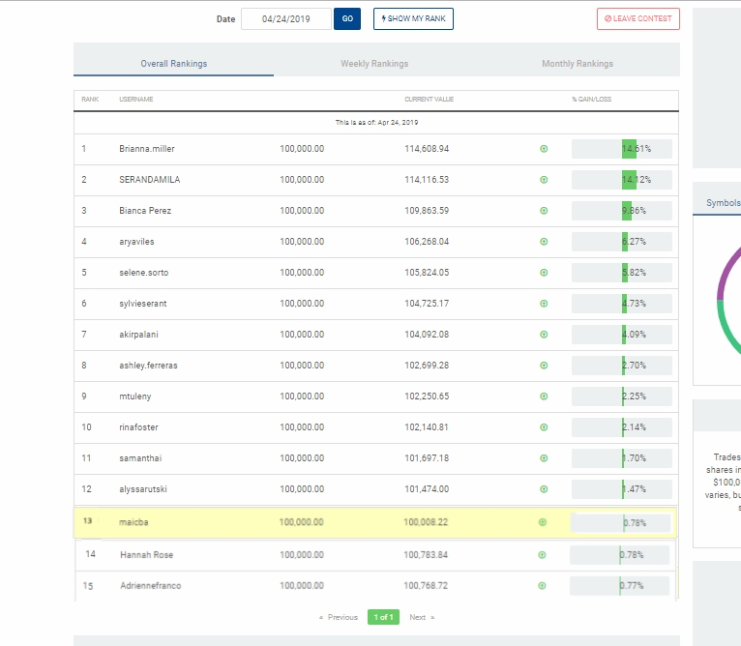
a screenshot showing the overall rank.

